HUMAN COMPUTER INTERACTION
J-COMPONENT
REVIEW 2
SLOT- A2

SUBMITTED TO:
PROF. DHEEBA J

NAME: SWATTIK MAITI
REGNO: 18BCE0995

A SHOPPING STORE FOR MEN'S FASHION .

Evaluation of website design using the Sneiderman's golden rule :

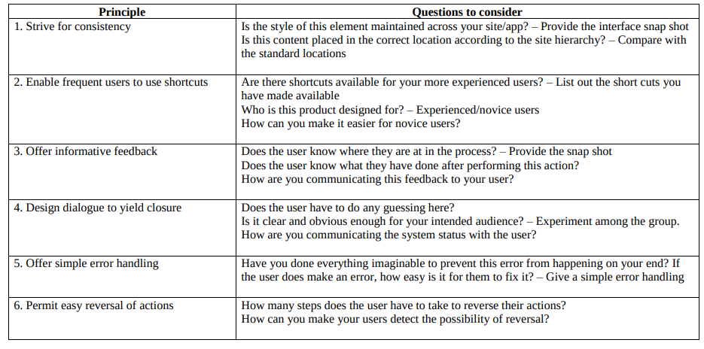
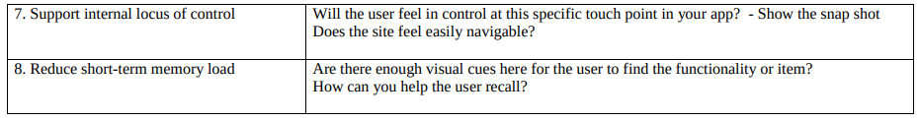

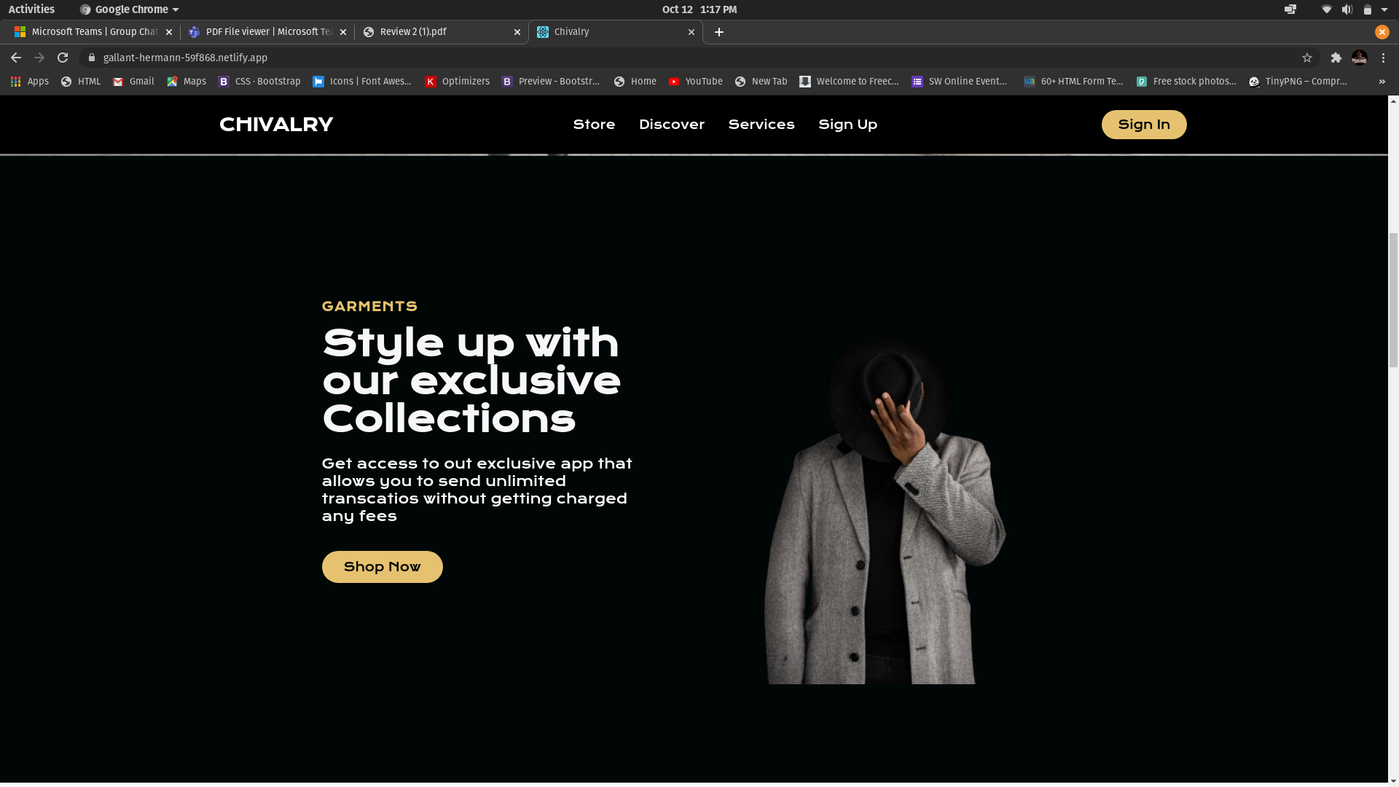
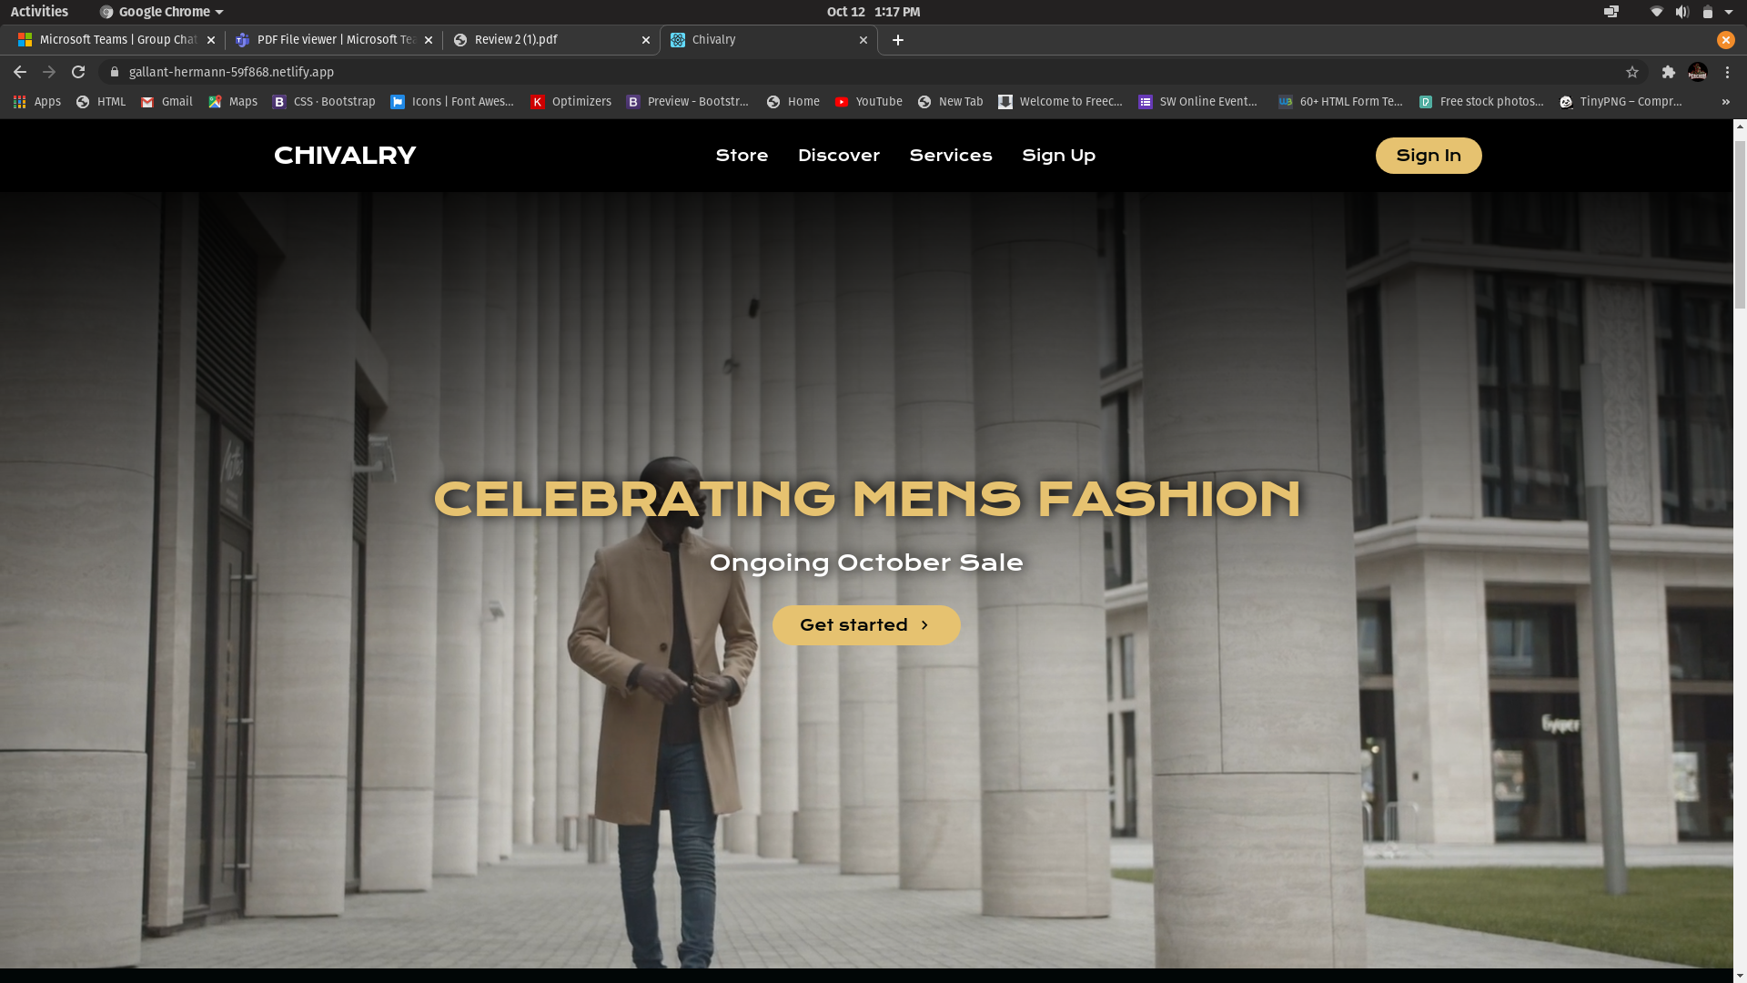
1. Strive for consistency

The design of the site is consistent as can be seen in the snapshot. The same font is used throughout the website. The button elements have the same design and is easily distinguishable.
The colors and gradients used are also consistent avoiding the use of too many colors to confuse the user.
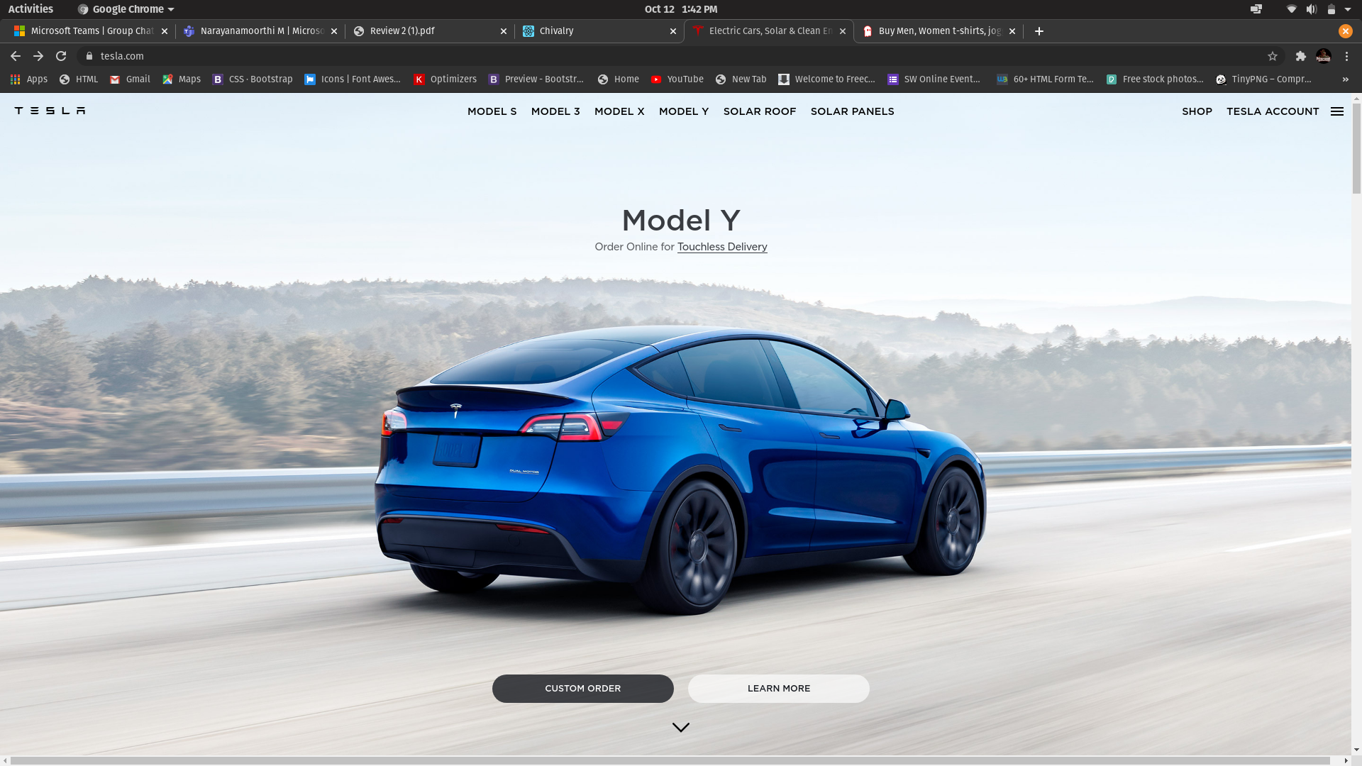
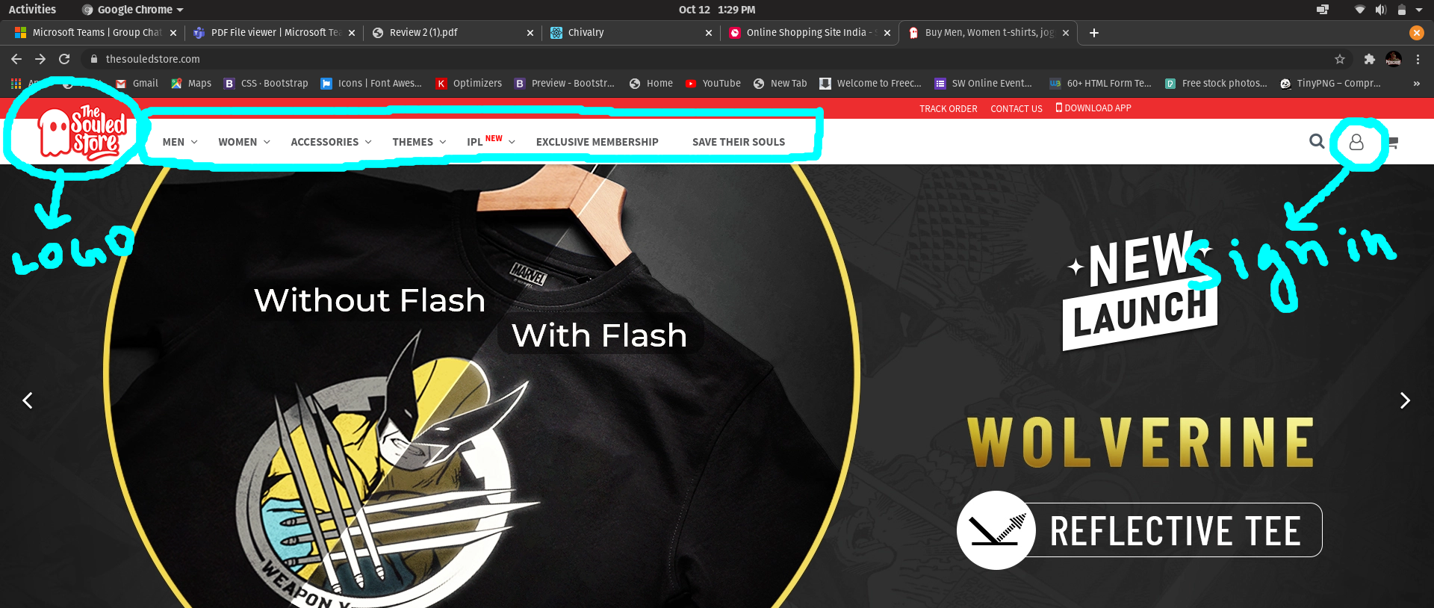
The content of the site are placed in their rightful positions according to hierarchy. This can be seen from the Navbar which has the company logo on the left most side and sign in button on the right most side, both on the top of the page and easily visible to the user as they are used the most. The midsection of the navbar contains the contents of the site.

Souled Store website follows a similarly designed Navbar as can be seen from the snapshot.

Tesla website also follows a very similar hierarchy. The navbar is very similar and then main Hero section with the buttons guiding to the rest of the site is also included in my website.

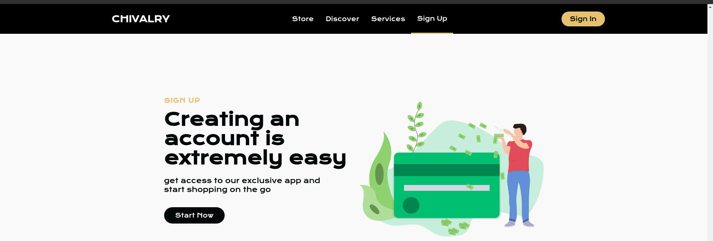
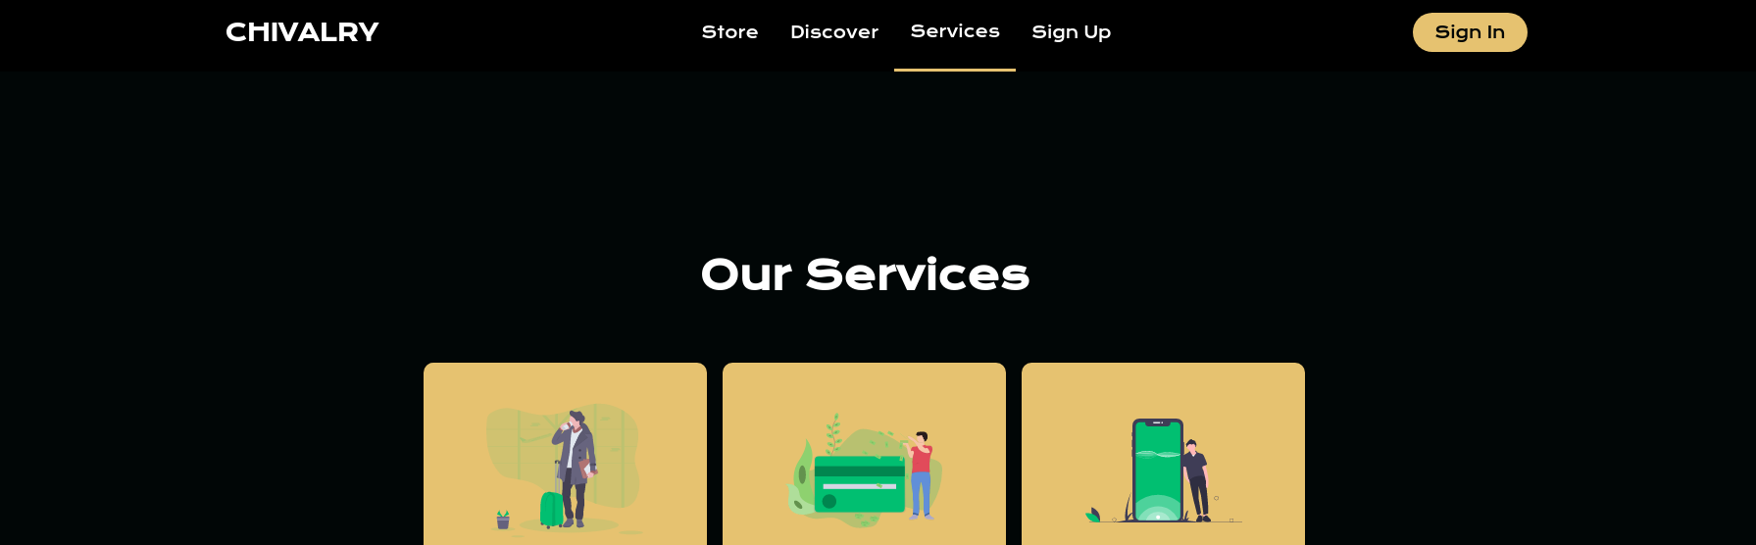
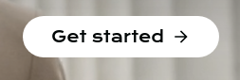

2. Enable frequent users to use shortcuts:

Frequent users can click on any of the section links in navbar and the smooth scroll embedded in the site will automatically scroll the page and stop in the specific section.

A search bar will also be there beside the sign in button for frequent users who want to search for a specific product rather than going through the whole site.
As this is an e-commerce website, the product is designed for both experienced as well as novice users.

For novice users the site has been made extremely simple and minimalist.

- Hover Effects have been placed on every button so that the user knows what he is clicking.

- A lower border effect is attacked to the links in navbar so that the user knows which section of the site he is currently viewing or wants to view.

- Section to guide new users on how to sign up.

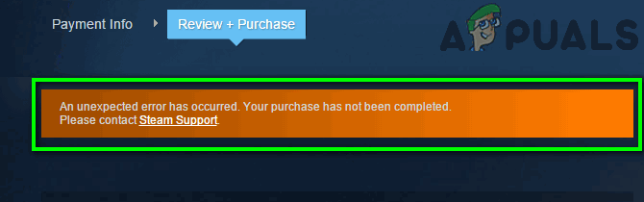
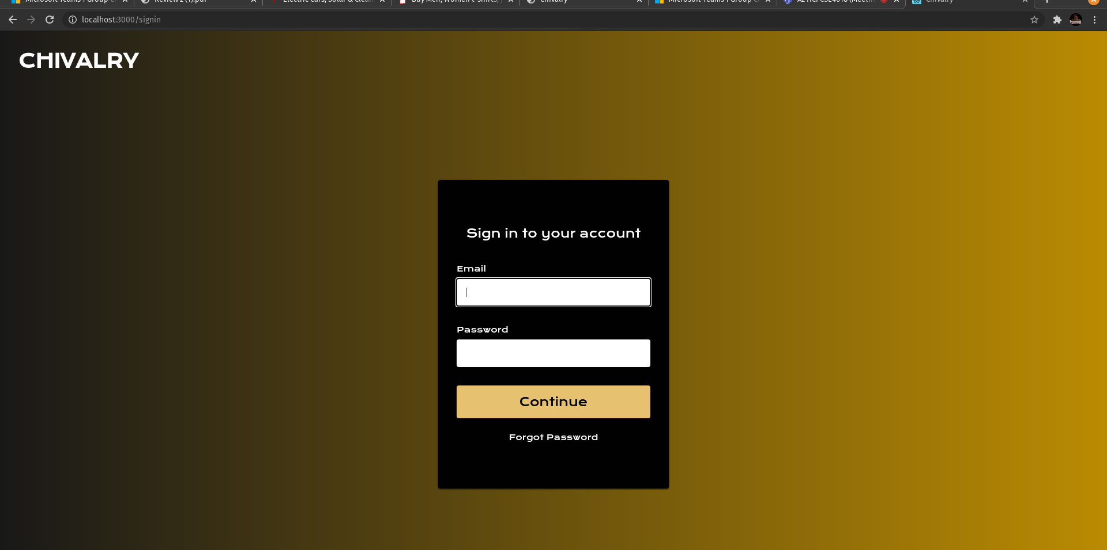
3. Offer informative Feedback

The user knows where they are in the process as each section is well labeled as can be seen from the snapshots.

To give user feedback about a successful action, javascript alert message boxes will be used.

4. Design Dialog to yield closure

No, the user doesn’t have to guess in any stage of using the website. Every section is well labeled and with user feedback.

To communicate the system status such as the payment status in the process of transaction, I plan to use a mixture of texts and symbols such as:

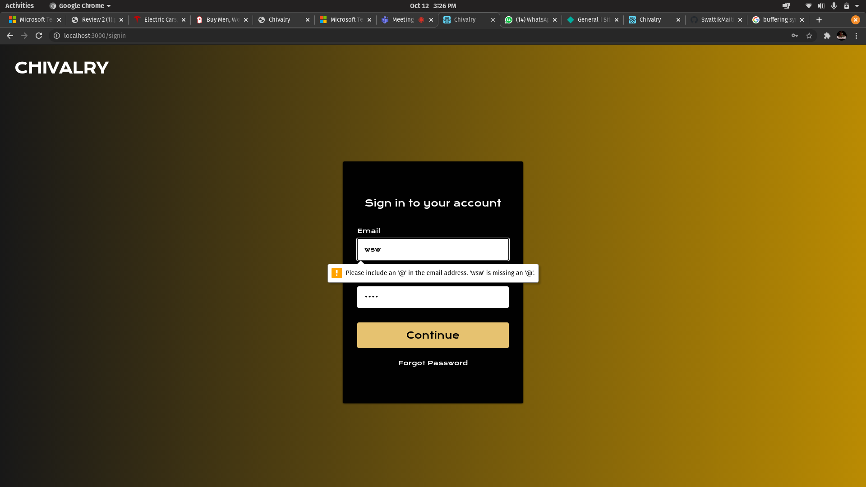

While a process is going on, we can use the following symbol and animation:

5. Offer simple error handling

Since the site is very simple and chances of major error from users end is minimal. If there are any click errors and the user is directed to a diff section, then navigation bar enables him to quickly correct his error and directs him to the target section.

In the Sign In page, the forgot password link is there which is basic error correcting method.

The text validation also directs the user on the format of the email, incase he mistypes his email or enters and invalid email. This is shown in the above figure.

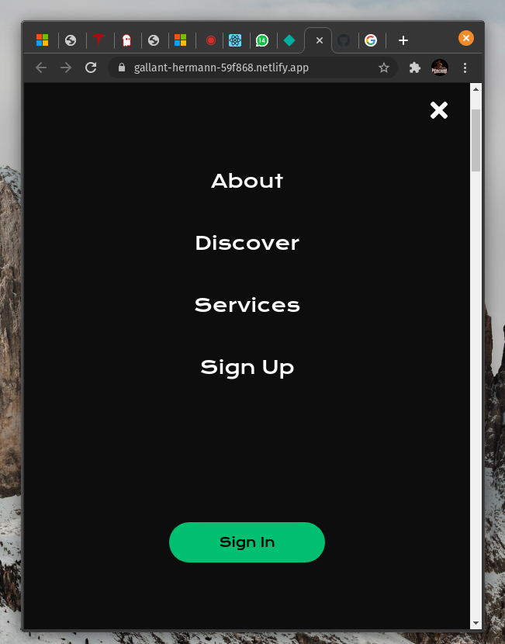
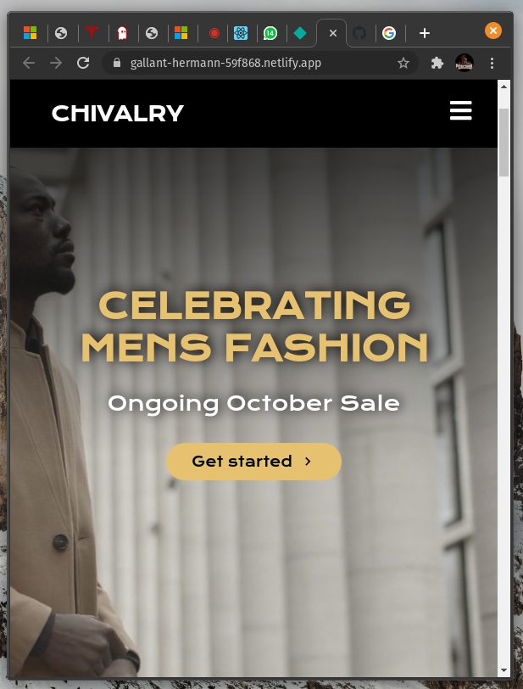
6. Permit easy reversal of actions

The user has to take one or maximum 2 steps to reverse an action. Under most cases just a click of a button will take the user to the previous or the interested stage.

7. Support internal locus of control

The mobile version of the app is very user friendly. The navigation bar sinks into a hamburger icon which is clearly visible and very simple to use. On clicking the icon the navbar drops down. This is shown in the snapshot below.

On clicking on the cross icon the nav bar sinks back. Thus we can conclude the site is easily navigable.


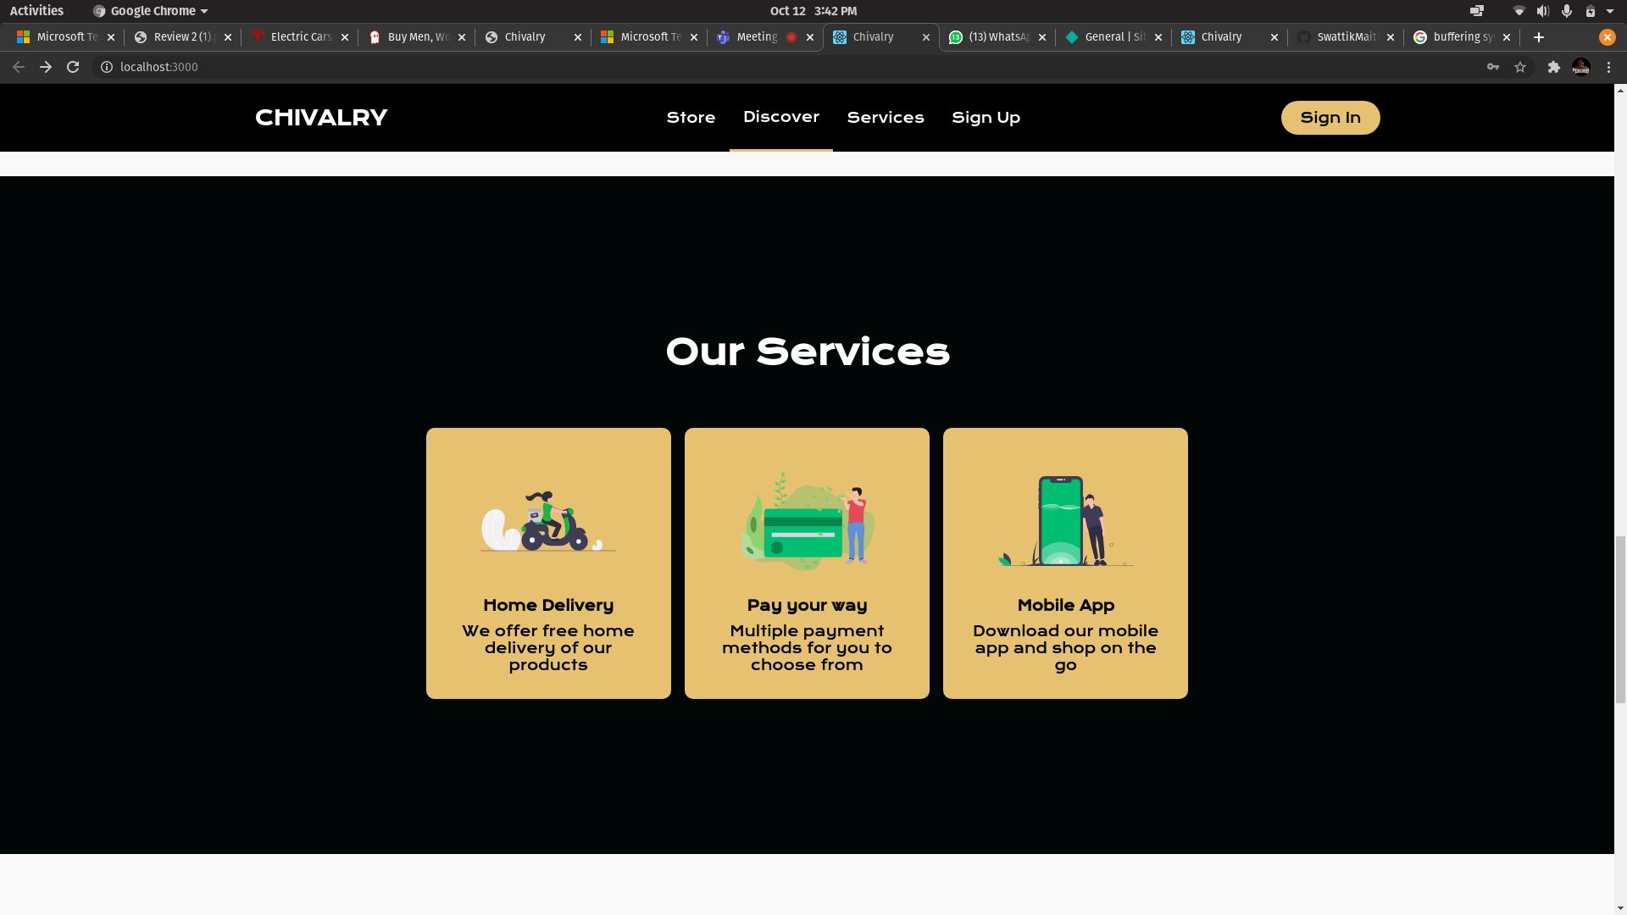
8. Reduce short term memory load

The website is full of icons and symbols. It follows the principle of “recognition over recall” at every point. The following snapshot proves this point.

We can see how every service is well represented with an SVG icon, so that the user can quickly understand what he is clicking on.

Another instance of this process of helping the user recognise instead of recall is in the footer.
All the social media links are represented by their respective logos.

In this way the users short term memory load is reduced.

